**ST. XAVIER’S COLLEGE**

**(Affiliated to Tribhuvan University)**

Maitighar, Kathmandu



**COMPUTER GRAPHICS**

**LAB ASSIGNMENT#1**

**Submitted by:**

Shreesha Pokharel

013BSCCSIT038

**Submitted to:**

|  |  |
| --- | --- |
| **Er. Anil K. Sah** |  |

Lecturer

Department of Computer Science

Date of submission: 4th August, 2015

**STATEMENT: DRAW THE FOLLOWING CHECKBOX.**

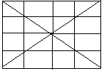

**SOURCE CODE:**

//---------------------------------------------------------------------------

#include <vcl\vcl.h>

#pragma hdrstop

#include "checkbox.h"

//---------------------------------------------------------------------------

#pragma resource "*.dfm"

TForm1 *Form1;

//---------------------------------------------------------------------------

__fastcall TForm1::TForm1(TComponent* Owner)

: TForm(Owner)

{

}

//---------------------------------------------------------------------------

void __fastcall TForm1::Button1Click(TObject *Sender)

{

Form1->Canvas->Pen->Width=2;

Form1->Canvas->Brush->Color=clWhite;

Form1->Canvas->Rectangle(10,10,250,150);

Form1->Canvas->MoveTo(10,10);

Form1->Canvas->LineTo(250,150);

Form1->Canvas->MoveTo(250,10);

Form1->Canvas->LineTo(10,150);

Form1->Canvas->MoveTo(10,80);

Form1->Canvas->LineTo(250,80);

Form1->Canvas->MoveTo(10,45);

Form1->Canvas->LineTo(250,45);

Form1->Canvas->MoveTo(10,115);

Form1->Canvas->LineTo(250,115);

Form1->Canvas->MoveTo(65,10);

Form1->Canvas->LineTo(65,150);

Form1->Canvas->MoveTo(130,10);

Form1->Canvas->LineTo(130,150);

Form1->Canvas->MoveTo(195,10);

Form1->Canvas->LineTo(195,150);

}

**OUTPUT:**

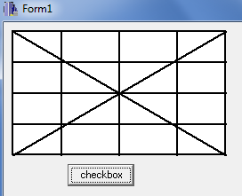

**CONCLUSION:**

Therefore, we could implement the checkbox using C++ builder efficiently with easy manipulation of the coordinates.

**REFERENCE:**

[1] D. Hearn and M. Baker, Computer Graphics, second edition.